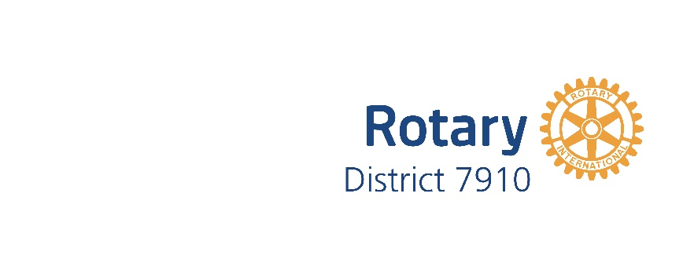
Rotary 7910 Quarterly District PR Meeting: FEBRUARY 6, 2017
6:30-8:00 PM Doubletree Leominster, 99 Erdman Way, Leominster, MA 01453
Agenda
- Introductions
- District 7910 Facebook page: update from Jason Camuti
- PI outreach to clubs across the district: status update from all
- Membership (request from the District Membership Committee to be on our agenda)
- Other/Roundtable
- Next meeting: May 3, 2017, location TBD

Introductions
Pat and Skip Doyle: Northborough
Jim Fusco: Montachusetts
Chris and Laura Spear: Nashoba Valley
Satya Mitra: Worcester

- District 7910 Facebook page
Jason was unable to attend, but he sent an update.
There does not seem to be a strong demand for a public-facing Facebook page for the district. We do have a District Facebook page today, but it is focused on Rotarians within the district. Clubs that do not have a Facebook page can take advantage of the existing district Facebook page, and club members could share the event or post for public consumption.
In the meantime, Steve Jones-D’Agostino has been posting newsletter content on the district Facebook page, including various club events and activities. A link to the Facebook page is in the weekly district newsletter. Pat has also been posting zone content.
Currently the Facebook page has 686 Likes and 655 Followers. We could run another contest to encourage posts, shares, and Likes, possibly focusing on Rotary trivia. Laura will follow up with Steve.
- PI outreach to clubs across the district: status update from all
Laura reviewed the few status updates she has received from the district Public Image (PI) committee members. Of the responses received, there does not seem to be a strong demand for district Public Image support. Of those clubs that responded, the majority said they do not need help with Public Relations. One club wanted regional media coverage, which is being done. One club wanted more internal resources (members) in order to do more public relations outreach. One club wanted materials to support membership recruitment. One club said it needed to discuss public image within the club to generate ideas. And, one club said we need to raise the awareness of Rotary in general and develop an image of the club as being attractive to younger people – this requires the club having similar members that they can showcase (proofpoints!).
The consensus is that the committee will continue to support requests from the clubs as they come in and continue to make training materials available.
Laura distributed a Rotary Writing Checklist and Resources for public image. She was asked to provide the links to the Resources as PR Tips for the weekly district newsletter. The Writing Checklist is at the end of these minutes. Keep in mind that our content “Avoids (or explains) Rotary terms.” This is important even for Rotary communications.
- Membership (request from the District Membership Committee to be on our agenda)
Communications for the four Membership workshops in March are underway. These workshops are a follow-on to the fall workshops, focusing on a member recruitment case study. Table facilitators and scribes will encourage and capture discussion. Attendees should bring their club brochures.
Satya said that external public relations helps encourage membership and that we should use Rotaract clubs to attract younger members. We also need to define our club meetings (meals, meeting times and locations, etc.) to support younger members. Clubs could use their newsletter to solicit members.
Laura reviewed a proposed “Buyer’s Journey” for obtaining members with supporting materials for each step in the process, most of which are already posted on the district website. It was agreed that she should document the process and make it available for the clubs, perhaps in video format.
Other input was that membership ideas and processes, along with other key club information, should be reinforced for the Presidents after PETS, about one to two months after their term has started.
The next district Membership meeting is February 15. See the district calendar for more information.
- Other/Roundtable
On May 25, a Foundation gala will be held in Mechanics Hall in Worcester.
- Next meeting: May 3, 2017, location TBD. Please mark your calendar. This will be the last District Public Image meeting that Laura will lead, as her term expires at the end of June.

Writing Checklist

Our Essence
⃝ Articulates how we connect leaders from all continents, cultures, and occupations—join leaders
⃝ Articulates how we discover and celebrate diverse perspectives—exchange ideas
⃝ Articulates how create positive change in our communities—take action

Our Values
⃝ Articulates how we build relationships—fellowship and global understanding
⃝ Articulates how we honor our commitments—integrity and ethics
⃝ Articulates how we connect diverse perspectives—diversity
⃝ Articulates how we apply our leadership and expertise to solve problems—vocational expertise, service, and leadership

Our Voice Attributes
⃝ Is bold, purposeful, and courageous; expresses our long-term commitment and determination to succeed; expresses our commitment when we speak with clarity and conviction—persevering
⃝ Is upbeat, hopeful, and visionary; compels others to take action; conveys hope, enthusiasm, and passion—inspiring
⃝ Is thoughtful, sincere, and engaging; expresses that we care; champions real people, stories, and conversations that are relatable and universal—compassionate
⃝ Comes across knowledgeable, perceptive, and confident; conveys our thought-leadership; is credible; is insightful and discerning—smart
⃝ Comes across “in voice”

Other
⃝ Written in an active voice
⃝ Uses personal pronouns
⃝ Avoids (or explains) Rotary terms
⃝ Focus is on “why” rather than “what”
⃝ Includes a clear call to action (join leaders, exchange ideas, take action)
⃝ Focuses impact locally before scaling globally
⃝ Focuses on connections and community rather than individuals
⃝ Free of unnecessary words
⃝ Intended audience is clear
⃝ Follows Rotary style guide

