**Change lives…..**

Framingham Rotary participates in a broad range of service activities designed to improve the lives of others. Many of these activities are suggested by our members while others are brought to us by the community. **Some examples of our recent success:**

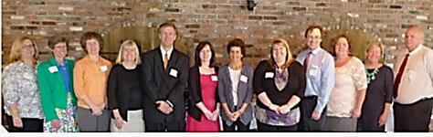**Presented** over $40,000 annually in Scholarships to High School Seniors

**Started***Feed Framingham* program to collect and serve food at local food pantries

**Purchased** air conditioners for Senior Citizens living in public housing

**Helped** prepare and serve Thanksgiving Dinner at the Eagle Club

**Collected** for Special Olympics at Boston Marathon

**Participated** in Career Days at Mass Bay CC

**Grants to Community Organizations:**

Our club’s fundraising efforts support several local non-profits and organizations that serve our area including:

Metrowest YMCA ◦ Knox Boy Scouts ◦ Concerts on the Common

Natick VNA ◦ Callahan Senior Center ◦ Bethany Hill School

A Place to Turn ◦ J.A. Mazie Mentors ◦ Boys & Girls Club

Advocates ◦ Performing Arts Center◦ Boston One Fund

Access TV ◦ Amazing Things Art Center ◦ Pearl St. Cafe

Framingham Historical Society ◦ Framingham Housing Authority

**Take Action…..**

There’s something that all Rotary club members have in common. **We take action**. As community volunteers, we reach out to neighbors in need. We build, support and organize. We work locally and globally. We feed the hungry. We save lives.

Around the world and around the corner, Rotary volunteers

* Get involved in their communities
* Connect with other professionals
* Share their time & experience with young people
* Make friends
* Use their skills to help others

**Become a Member .....**



Join now and help make a difference in our club, our community, the world. Whether you’re a veteran volunteer or brand new to community service, whether you’ve got lots of time or just a little, we’re looking for people who want to get involved.

For more info, please contact the Rotary Club of Framingham at [**info@framinghamrotery.org**](mailto:info@framinghamrotery.org)



**Get Involved…..**

**The Rotary Club of Framingham** began in 1922 and serves the communities of Ashland, Framingham, Holliston and Hopkinton. Our members meet regularly to plan and implement community service activities. Our long standing track record of service to others exemplifies our commitment to *Service Above Self*.

The club also has a strong commitment to the youth of our towns. We sponsor many Rotary programs aimed at teaching and energizing the next generation of community service leaders.

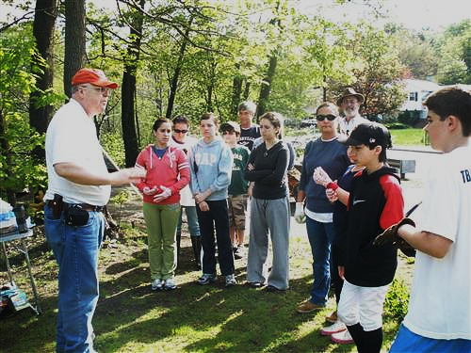

**Framingham Rotary’s Youth Programs:**

**Interact Clubs** (service organization for youth ages 12-18) at Fuller Middle School and FHS.

**RYLA** (Rotary’s leadership development program), annually sent 6 sophomores from area high schools.

Through **ESSEX,** Framingham Rotarywelcomed a foreign exchange student from Germany.

As part of **Rotary’s Ambassador Program,** the club mentored a college student from Austria through his year abroad at Harvard.

**Start-up of Rotoract Club planned** (service club for adults 18-30) at Framingham State University.

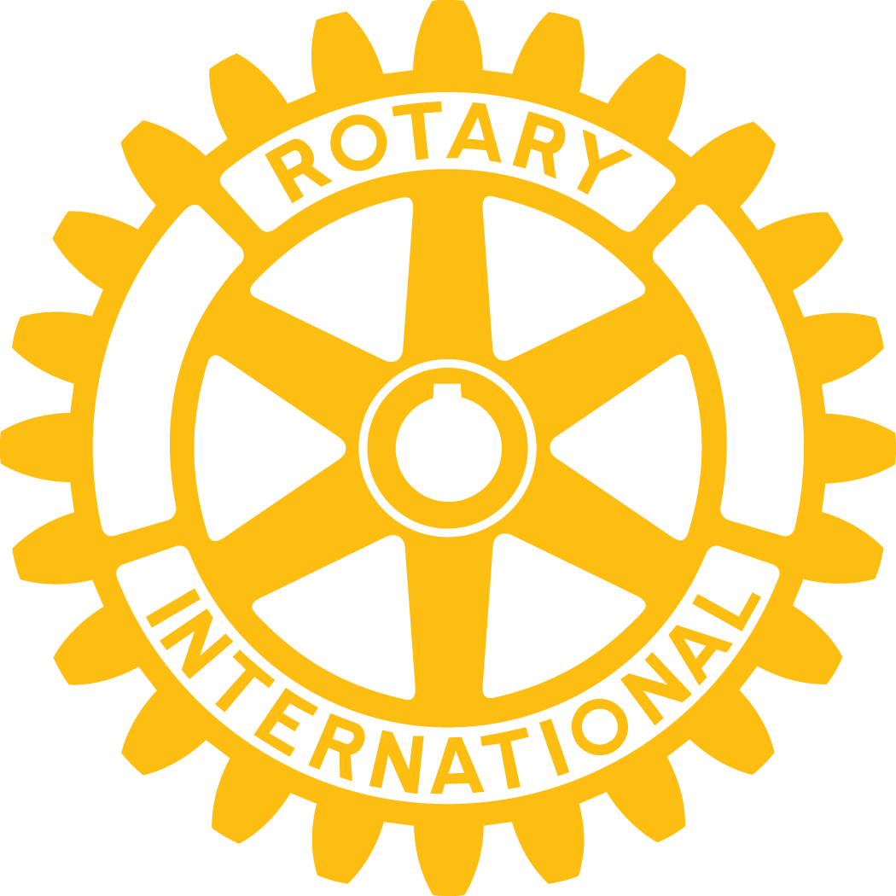

**The Rotary Club of Framingham**

***Service***

***Above Self***



**www.framinghamrotary.org**

info@framinghamrotary.org

**Engage Rotary……**

Rotary International. We are over 1.2 million neighbors, friends and community leaders who come together to create positive lasting change in our communities and our world.

Since 1905, we’ve taken on some of the world’s toughest challenges, like an adequate water supply in India, available healthcare in S. Korea and stamping out polio worldwide.

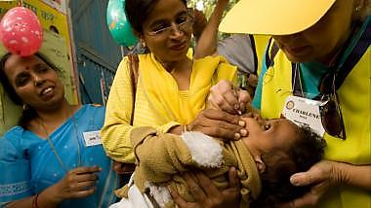

The heart of Rotary is our local clubs. People who share a passion for community and friendship. People who bring our world closer and make a difference through service activities in their own communities and through humanitarian aid overseas.

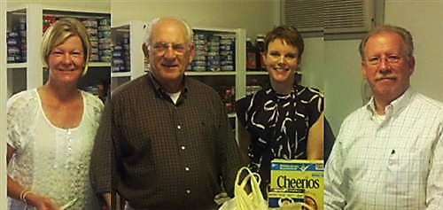

What began as an ideal over 100 years ago – ***Service Above Self*** *–* is now a successful standard in over 34,000 clubs in some 200 countries.

**Join us for Lunch……**

**You’re invited to enjoy a complimentary lunch on us.**

We meet every Monday at 12:15 pm for lunch at Ken’s Steak House in Framingham. The meeting starts with an introduction of visiting Rotarians and guests, followed by announcements of club activities and projects. Lunch gives us a chance to catch up with friends and make new acquaintances as well.

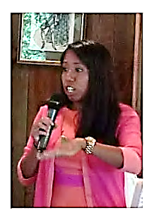

If you’re interested in joining Framingham Rotary and would like to attend a luncheon meeting, please contact us at **info@framinghamrotary.org.**

**Where we meet:**

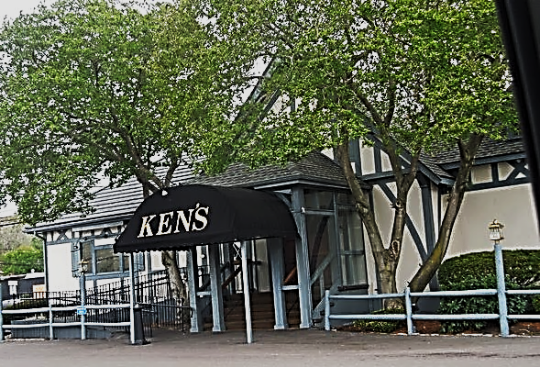

Each week we feature a guest speaker whose topic is important to our community or of special interest to our members. Meetings adjourn promptly at 1:30 pm.

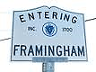

**Ken’s Steak House**

**95 Worcester Road (Rt. 9 West)**

**Framingham, MA**